# **28mm Brushless DC Planetary Gear Motor, 12V, 68RPM**

$30.50

<https://www.robotshop.com/products/e-s-motor-28mm-brushless-dc-planetary-gear-motor-12v-68rpm>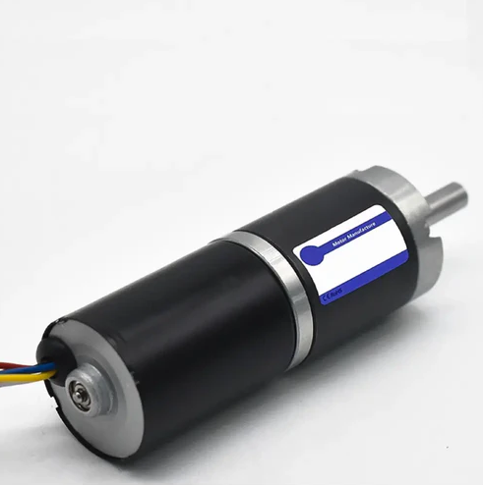

SKU: RM-ESMO-0M2

Model: 28PG 2838BL 25 12V

Gear Ratio: 1/88

Rated Voltage: 12V DC

No-Load Speed: 68 RPM

No-Load Current: 0.13 A

Rated Speed: 61 RPM

Rated Current: 0.33 A

Rated Torque: 3.25 kg-cm

Stall Torque: 8.5 kg-cm

Stall Current: 0.5 A

* Equipped with a built-in hall encoder, providing improved torque and high programmability
* Featuring two ball bearings, resulting in low running losses and a long service life
* Low mesh backlash, providing smooth operation and low noise levels
* Speed adjustable and capable of both clockwise and counterclockwise rotation

**Notes:**  
There are plenty of similar motors on Robot Workshop for this 28mm BLDC with various RPMs and Torques. For our cases, I think this motor will suit our needs with the low RPMs and rated torque.

# 

# **RioRand 350W 6-60V PWM DC Brushless Electric Motor Speed Controller with Hall**

$18.99

<https://www.amazon.com/RioRand-Brushless-Electric-Controller-Hall-Less/dp/B087M3GVYX/?_encoding=UTF8&pd_rd_w=QoL3K&content-id=amzn1.sym.cc935104-dbfb-4cb7-accc-e3698feac895%3Aamzn1.symc.da37c481-c687-45c0-9f6a-b1d01f510202&pf_rd_p=cc935104-dbfb-4cb7-accc-e3698feac895&pf_rd_r=7WJGP2J2Y1703ZQ8V409&pd_rd_wg=gCxSq&pd_rd_r=1f46143c-292f-45b9-81bd-3ce82b8358d5&ref_=pd_hp_d_atf_ci_mcx_mr_ca_hp_atf_d&th=1>

Working voltage：6-60V（limit 60V leave a margin for use）

Operating current: rated 16A peak 20A

Power: rated 200-300W peak 350W (leave a margin to strengthen heat dissipation when using large power)

Overcurrent protection: Yes

**Notes:**

This is a familiar motor controller to me, I **think\*** these are the same ones used in Dr. Isaacs’s mobile robotic course as I remember soldering the External 0-5V analog input together.

We might need to get 1 motor controller per motor I think

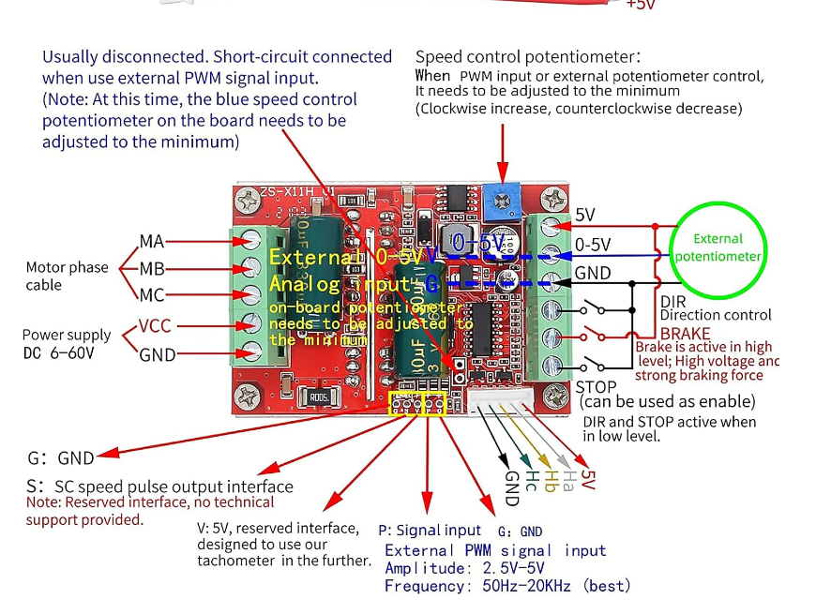

From the store:  
*1. Because the forward and reverse rotation is no delay hard commutation, and the brake will have a large impact, so you can not operate these two functions at high voltage full speed operation, forced operation may damage the power tube and chip, the need to speed control throttle down to 50% below before operation.*

*2. The maximum voltage (60V) and maximum power (350W) marked in this module are the limit parameters under specific conditions, so the actual application should leave a margin for use.*

NEW MOTOR SELECTION!!!!! -_-